Torso-yaw repair

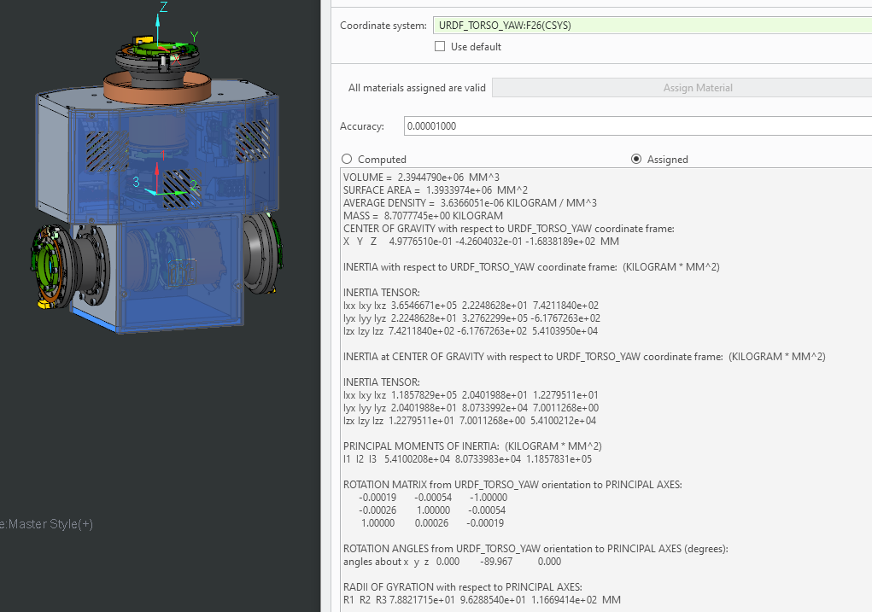

VOLUME = 2.3944790e+06 MM^3

SURFACE AREA = 1.3933974e+06 MM^2

AVERAGE DENSITY = 3.6366051e-06 KILOGRAM / MM^3

MASS = 8.7077745e+00 KILOGRAM

CENTER OF GRAVITY with respect to URDF_TORSO_YAW coordinate frame:

X Y Z 4.9776510e-01 -4.2604032e-01 -1.6838189e+02 MM

INERTIA with respect to URDF_TORSO_YAW coordinate frame: (KILOGRAM * MM^2)

INERTIA TENSOR:

Ixx Ixy Ixz 3.6546671e+05 2.2248628e+01 7.4211840e+02

Iyx Iyy Iyz 2.2248628e+01 3.2762299e+05 -6.1767263e+02

Izx Izy Izz 7.4211840e+02 -6.1767263e+02 5.4103950e+04

INERTIA at CENTER OF GRAVITY with respect to URDF_TORSO_YAW coordinate frame: (KILOGRAM * MM^2)

INERTIA TENSOR:

Ixx Ixy Ixz 1.1857829e+05 2.0401988e+01 1.2279511e+01

Iyx Iyy Iyz 2.0401988e+01 8.0733992e+04 7.0011268e+00

Izx Izy Izz 1.2279511e+01 7.0011268e+00 5.4100212e+04

PRINCIPAL MOMENTS OF INERTIA: (KILOGRAM * MM^2)

I1 I2 I3 5.4100208e+04 8.0733983e+04 1.1857831e+05

ROTATION MATRIX from URDF_TORSO_YAW orientation to PRINCIPAL AXES:

-0.00019 -0.00054 -1.00000

-0.00026 1.00000 -0.00054

1.00000 0.00026 -0.00019

ROTATION ANGLES from URDF_TORSO_YAW orientation to PRINCIPAL AXES (degrees):

angles about x y z 0.000 -89.967 0.000

RADII OF GYRATION with respect to PRINCIPAL AXES:

R1 R2 R3 7.8821715e+01 9.6288540e+01 1.1669414e+02 MM

Shoulder-pitch (right)

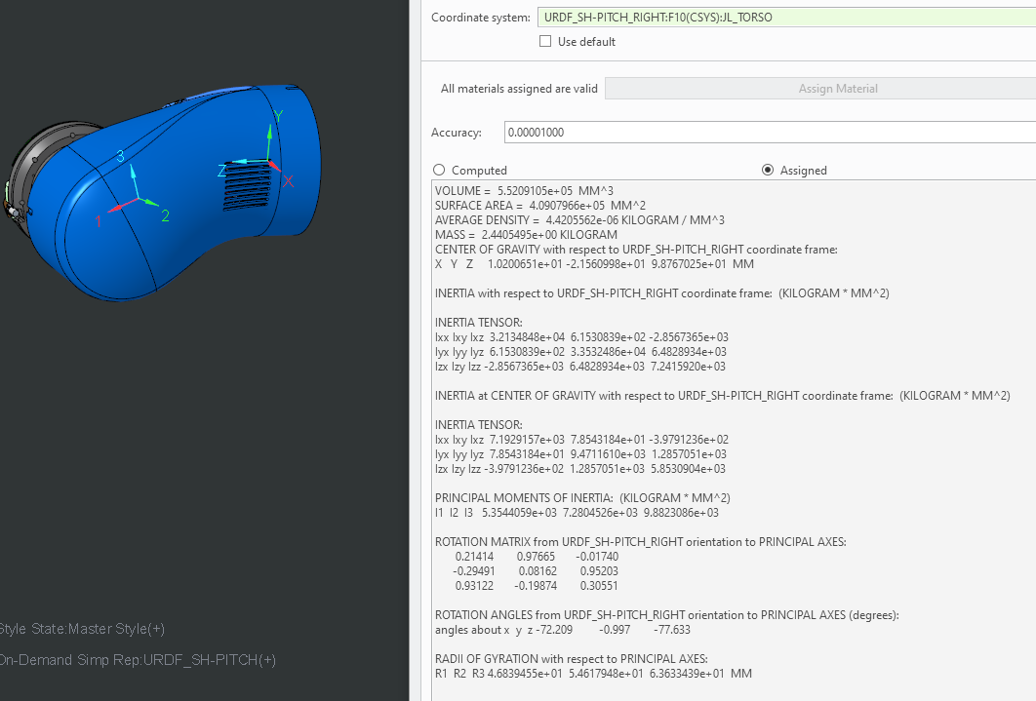

VOLUME = 5.5209105e+05 MM^3

SURFACE AREA = 4.0907966e+05 MM^2

AVERAGE DENSITY = 4.4205562e-06 KILOGRAM / MM^3

MASS = 2.4405495e+00 KILOGRAM **REAL Mass** = 2.347

CENTER OF GRAVITY with respect to URDF_SH-PITCH_RIGHT coordinate frame:

X Y Z 1.0200651e+01 -2.1560998e+01 9.8767025e+01 MM

INERTIA with respect to URDF_SH-PITCH_RIGHT coordinate frame: (KILOGRAM * MM^2)

INERTIA TENSOR:

Ixx Ixy Ixz 3.2134848e+04 6.1530839e+02 -2.8567365e+03

Iyx Iyy Iyz 6.1530839e+02 3.3532486e+04 6.4828934e+03

Izx Izy Izz -2.8567365e+03 6.4828934e+03 7.2415920e+03

INERTIA at CENTER OF GRAVITY with respect to URDF_SH-PITCH_RIGHT coordinate frame: (KILOGRAM * MM^2)

INERTIA TENSOR:

Ixx Ixy Ixz 7.1929157e+03 7.8543184e+01 -3.9791236e+02

Iyx Iyy Iyz 7.8543184e+01 9.4711610e+03 1.2857051e+03

Izx Izy Izz -3.9791236e+02 1.2857051e+03 5.8530904e+03

PRINCIPAL MOMENTS OF INERTIA: (KILOGRAM * MM^2)

I1 I2 I3 5.3544059e+03 7.2804526e+03 9.8823086e+03

ROTATION MATRIX from URDF_SH-PITCH_RIGHT orientation to PRINCIPAL AXES:

0.21414 0.97665 -0.01740

-0.29491 0.08162 0.95203

0.93122 -0.19874 0.30551

ROTATION ANGLES from URDF_SH-PITCH_RIGHT orientation to PRINCIPAL AXES (degrees):

angles about x y z -72.209 -0.997 -77.633

RADII OF GYRATION with respect to PRINCIPAL AXES:

R1 R2 R3 4.6839455e+01 5.4617948e+01 6.3633439e+01 MM

T matrix “torso-yaw” to “sh-Pitch”

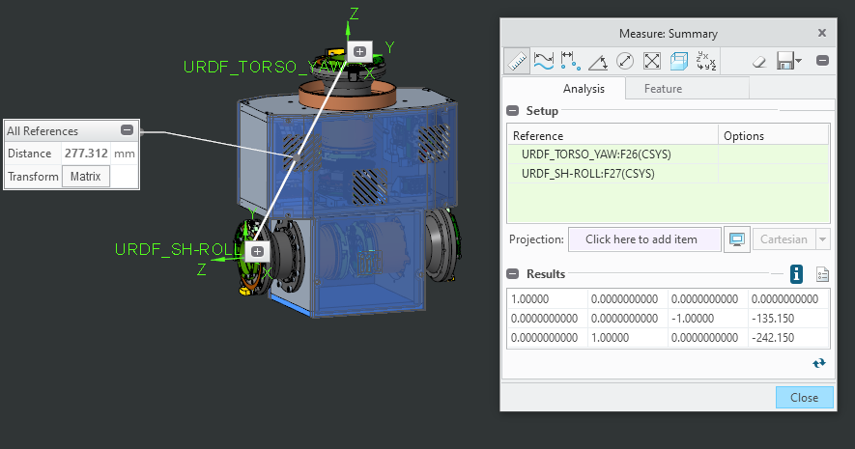

Shoulder-roll

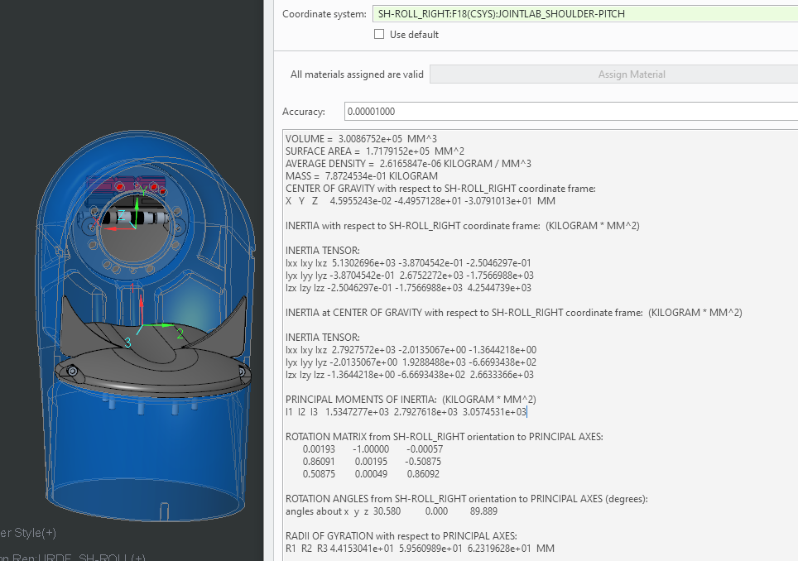

VOLUME = 3.0086752e+05 MM^3

SURFACE AREA = 1.7179152e+05 MM^2

AVERAGE DENSITY = 2.6165847e-06 KILOGRAM / MM^3

MASS = 7.8724534e-01 KILOGRAM **REAL Mass** = 0.76

CENTER OF GRAVITY with respect to SH-ROLL_RIGHT coordinate frame:

X Y Z 4.5955243e-02 -4.4957128e+01 -3.0791013e+01 MM

INERTIA with respect to SH-ROLL_RIGHT coordinate frame: (KILOGRAM * MM^2)

INERTIA TENSOR:

Ixx Ixy Ixz 5.1302696e+03 -3.8704542e-01 -2.5046297e-01

Iyx Iyy Iyz -3.8704542e-01 2.6752272e+03 -1.7566988e+03

Izx Izy Izz -2.5046297e-01 -1.7566988e+03 4.2544739e+03

INERTIA at CENTER OF GRAVITY with respect to SH-ROLL_RIGHT coordinate frame: (KILOGRAM * MM^2)

INERTIA TENSOR:

Ixx Ixy Ixz 2.7927572e+03 -2.0135067e+00 -1.3644218e+00

Iyx Iyy Iyz -2.0135067e+00 1.9288488e+03 -6.6693438e+02

Izx Izy Izz -1.3644218e+00 -6.6693438e+02 2.6633366e+03

PRINCIPAL MOMENTS OF INERTIA: (KILOGRAM * MM^2)

I1 I2 I3 1.5347277e+03 2.7927618e+03 3.0574531e+03

ROTATION MATRIX from SH-ROLL_RIGHT orientation to PRINCIPAL AXES:

0.00193 -1.00000 -0.00057

0.86091 0.00195 -0.50875

0.50875 0.00049 0.86092

ROTATION ANGLES from SH-ROLL_RIGHT orientation to PRINCIPAL AXES (degrees):

angles about x y z 30.580 0.000 89.889

RADII OF GYRATION with respect to PRINCIPAL AXES:

R1 R2 R3 4.4153041e+01 5.9560989e+01 6.2319628e+01 MM

T matrix “sh-pitch” to “sh-roll”

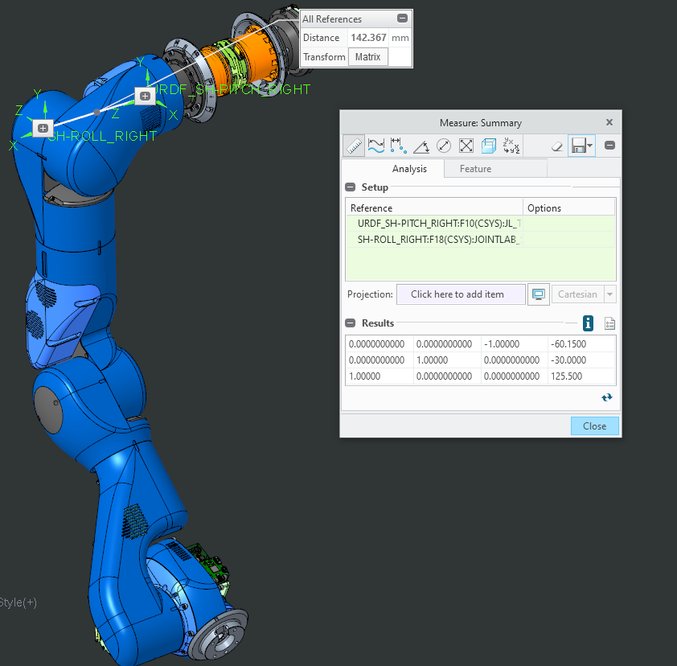

Shoulder-yaw

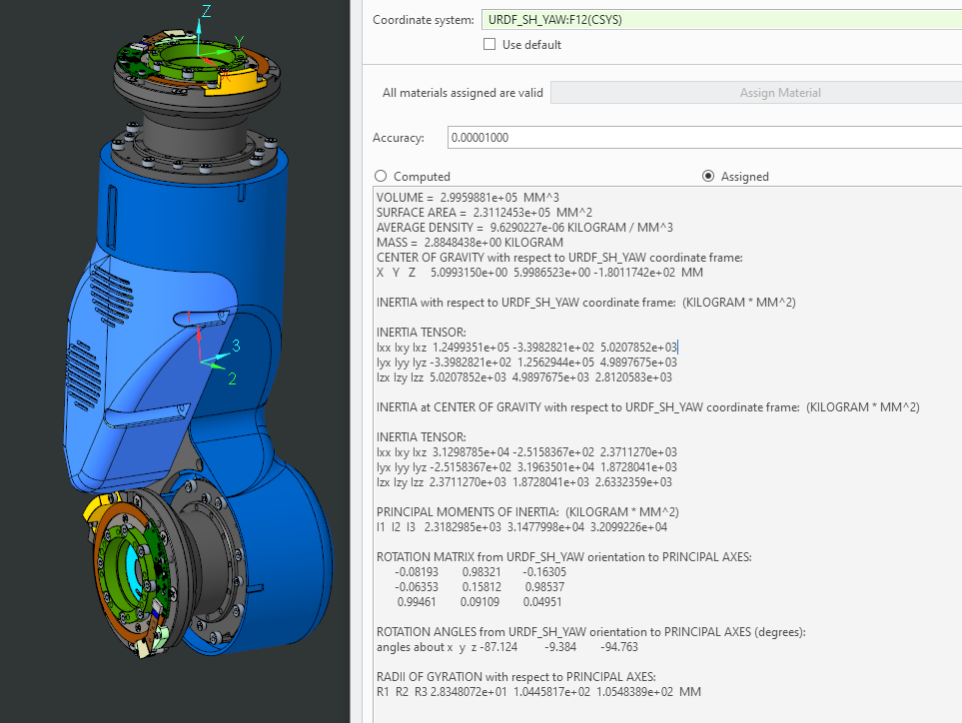

VOLUME = 2.9959881e+05 MM^3

SURFACE AREA = 2.3112453e+05 MM^2

AVERAGE DENSITY = 9.6290227e-06 KILOGRAM / MM^3

MASS = 2.8848438e+00 KILOGRAM **REAL Mass** =3.34

CENTER OF GRAVITY with respect to URDF_SH_YAW coordinate frame:

X Y Z 5.0993150e+00 5.9986523e+00 -1.8011742e+02 MM

INERTIA with respect to URDF_SH_YAW coordinate frame: (KILOGRAM * MM^2)

INERTIA TENSOR:

Ixx Ixy Ixz 1.2499351e+05 -3.3982821e+02 5.0207852e+03

Iyx Iyy Iyz -3.3982821e+02 1.2562944e+05 4.9897675e+03

Izx Izy Izz 5.0207852e+03 4.9897675e+03 2.8120583e+03

INERTIA at CENTER OF GRAVITY with respect to URDF_SH_YAW coordinate frame: (KILOGRAM * MM^2)

INERTIA TENSOR:

Ixx Ixy Ixz 3.1298785e+04 -2.5158367e+02 2.3711270e+03

Iyx Iyy Iyz -2.5158367e+02 3.1963501e+04 1.8728041e+03

Izx Izy Izz 2.3711270e+03 1.8728041e+03 2.6332359e+03

PRINCIPAL MOMENTS OF INERTIA: (KILOGRAM * MM^2)

I1 I2 I3 2.3182985e+03 3.1477998e+04 3.2099226e+04

ROTATION MATRIX from URDF_SH_YAW orientation to PRINCIPAL AXES:

-0.08193 0.98321 -0.16305

-0.06353 0.15812 0.98537

0.99461 0.09109 0.04951

ROTATION ANGLES from URDF_SH_YAW orientation to PRINCIPAL AXES (degrees):

angles about x y z -87.124 -9.384 -94.763

RADII OF GYRATION with respect to PRINCIPAL AXES:

R1 R2 R3 2.8348072e+01 1.0445817e+02 1.0548389e+02 MM

T matrix “sh-roll” to “sh-yaw”

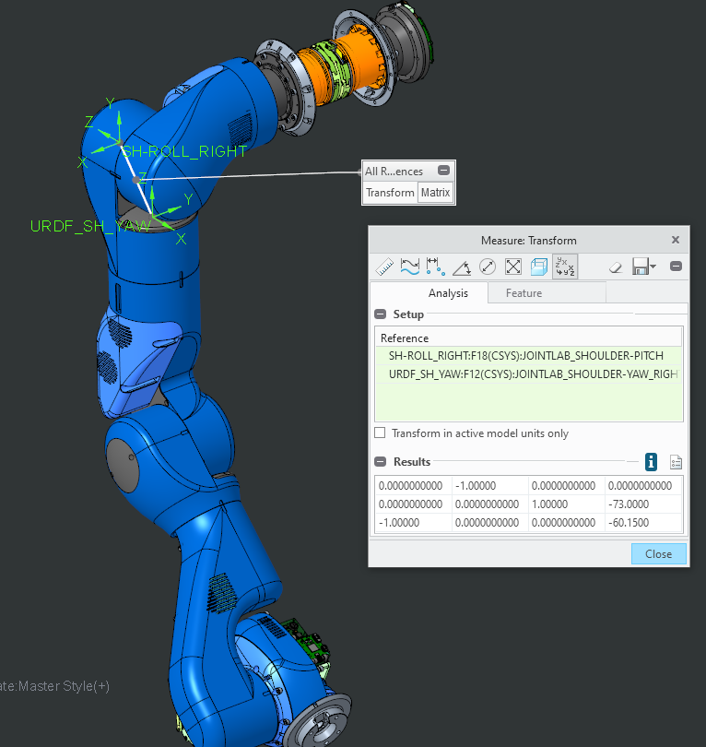

Elbow

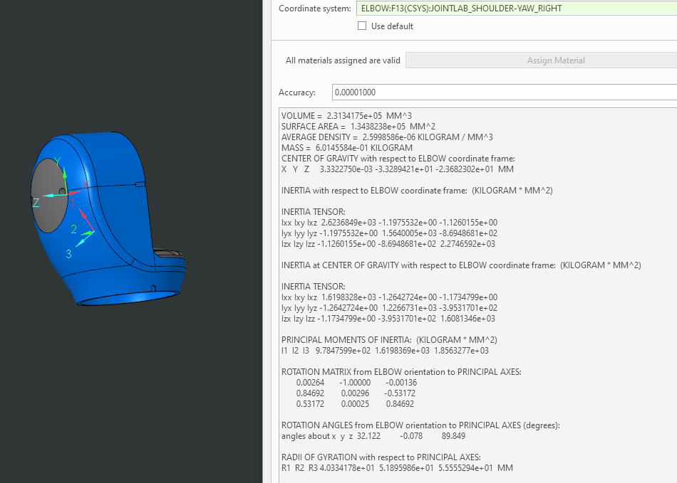

VOLUME = 2.3134175e+05 MM^3

SURFACE AREA = 1.3438238e+05 MM^2

AVERAGE DENSITY = 2.5998586e-06 KILOGRAM / MM^3

MASS = 6.0145584e-01 KILOGRAM **REAL Mass** =0.55

CENTER OF GRAVITY with respect to ELBOW coordinate frame:

X Y Z 3.3322750e-03 -3.3289421e+01 -2.3682302e+01 MM

INERTIA with respect to ELBOW coordinate frame: (KILOGRAM * MM^2)

INERTIA TENSOR:

Ixx Ixy Ixz 2.6236849e+03 -1.1975532e+00 -1.1260155e+00

Iyx Iyy Iyz -1.1975532e+00 1.5640005e+03 -8.6948681e+02

Izx Izy Izz -1.1260155e+00 -8.6948681e+02 2.2746592e+03

INERTIA at CENTER OF GRAVITY with respect to ELBOW coordinate frame: (KILOGRAM * MM^2)

INERTIA TENSOR:

Ixx Ixy Ixz 1.6198328e+03 -1.2642724e+00 -1.1734799e+00

Iyx Iyy Iyz -1.2642724e+00 1.2266731e+03 -3.9531701e+02

Izx Izy Izz -1.1734799e+00 -3.9531701e+02 1.6081346e+03

PRINCIPAL MOMENTS OF INERTIA: (KILOGRAM * MM^2)

I1 I2 I3 9.7847599e+02 1.6198369e+03 1.8563277e+03

ROTATION MATRIX from ELBOW orientation to PRINCIPAL AXES:

0.00264 -1.00000 -0.00136

0.84692 0.00296 -0.53172

0.53172 0.00025 0.84692

ROTATION ANGLES from ELBOW orientation to PRINCIPAL AXES (degrees):

angles about x y z 32.122 -0.078 89.849

RADII OF GYRATION with respect to PRINCIPAL AXES:

R1 R2 R3 4.0334178e+01 5.1895986e+01 5.5555294e+01 MM

Tmatrix “sh-yaw” to “Elbow”

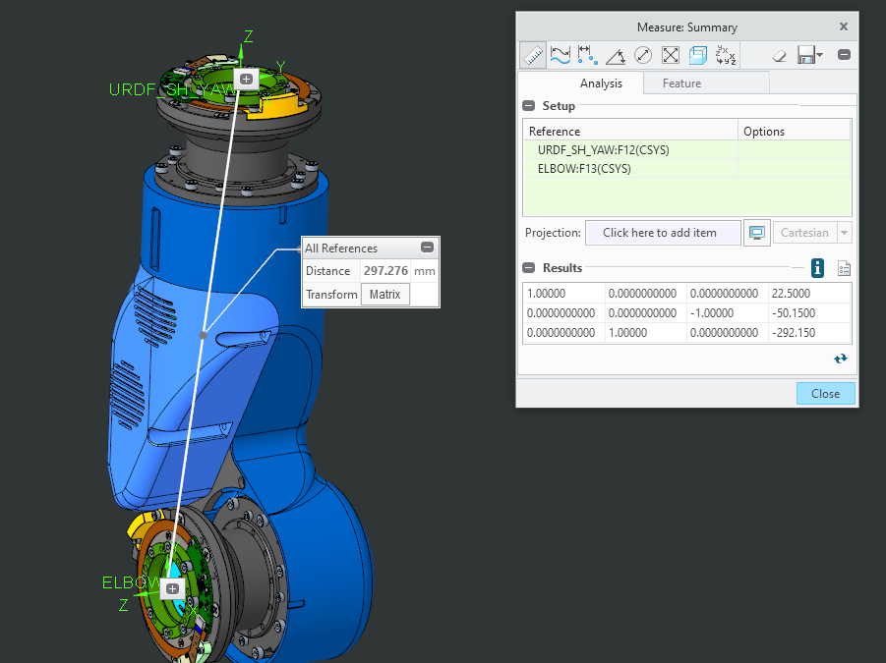

Forearm –yaw

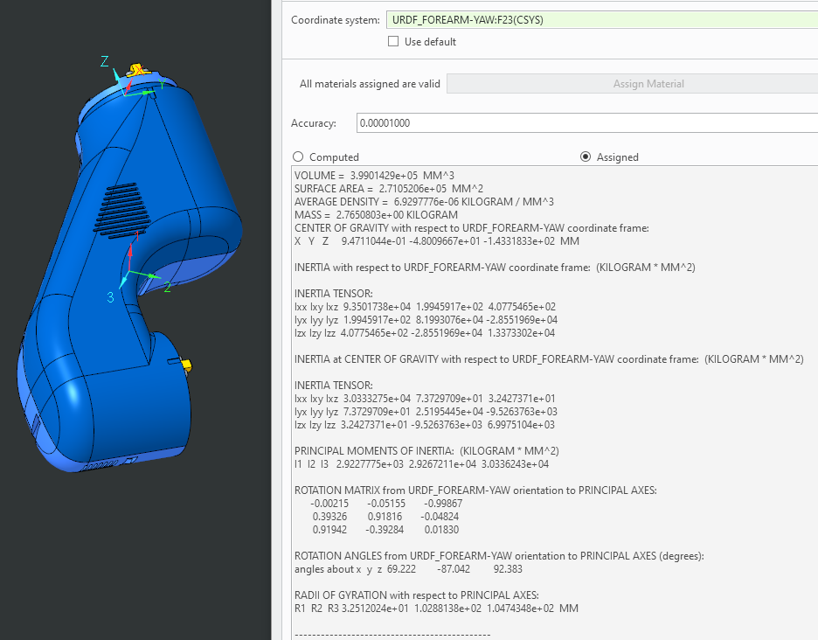

VOLUME = 3.9901429e+05 MM^3

SURFACE AREA = 2.7105206e+05 MM^2

AVERAGE DENSITY = 6.9297776e-06 KILOGRAM / MM^3

MASS = 2.7650803e+00 KILOGRAM **REAL Mass** =2.825

CENTER OF GRAVITY with respect to URDF_FOREARM-YAW coordinate frame:

X Y Z 9.4711044e-01 -4.8009667e+01 -1.4331833e+02 MM

INERTIA with respect to URDF_FOREARM-YAW coordinate frame: (KILOGRAM * MM^2)

INERTIA TENSOR:

Ixx Ixy Ixz 9.3501738e+04 1.9945917e+02 4.0775465e+02

Iyx Iyy Iyz 1.9945917e+02 8.1993076e+04 -2.8551969e+04

Izx Izy Izz 4.0775465e+02 -2.8551969e+04 1.3373302e+04

INERTIA at CENTER OF GRAVITY with respect to URDF_FOREARM-YAW coordinate frame: (KILOGRAM * MM^2)

INERTIA TENSOR:

Ixx Ixy Ixz 3.0333275e+04 7.3729709e+01 3.2427371e+01

Iyx Iyy Iyz 7.3729709e+01 2.5195445e+04 -9.5263763e+03

Izx Izy Izz 3.2427371e+01 -9.5263763e+03 6.9975104e+03

PRINCIPAL MOMENTS OF INERTIA: (KILOGRAM * MM^2)

I1 I2 I3 2.9227775e+03 2.9267211e+04 3.0336243e+04

ROTATION MATRIX from URDF_FOREARM-YAW orientation to PRINCIPAL AXES:

-0.00215 -0.05155 -0.99867

0.39326 0.91816 -0.04824

0.91942 -0.39284 0.01830

ROTATION ANGLES from URDF_FOREARM-YAW orientation to PRINCIPAL AXES (degrees):

angles about x y z 69.222 -87.042 92.383

RADII OF GYRATION with respect to PRINCIPAL AXES:

R1 R2 R3 3.2512024e+01 1.0288138e+02 1.0474348e+02 MM

T matrix “elbow” to “forearm-yaw”

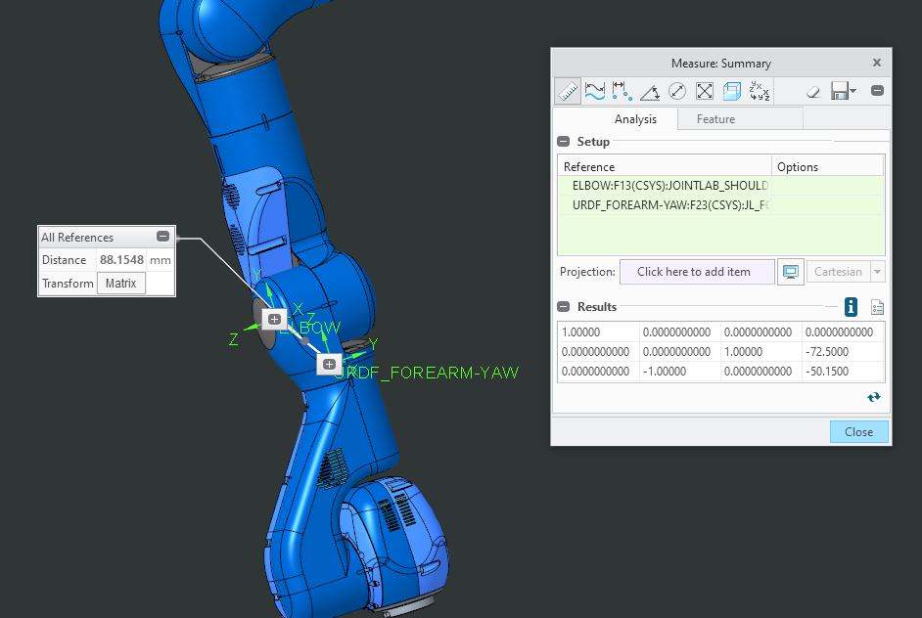

Wrist-pitch

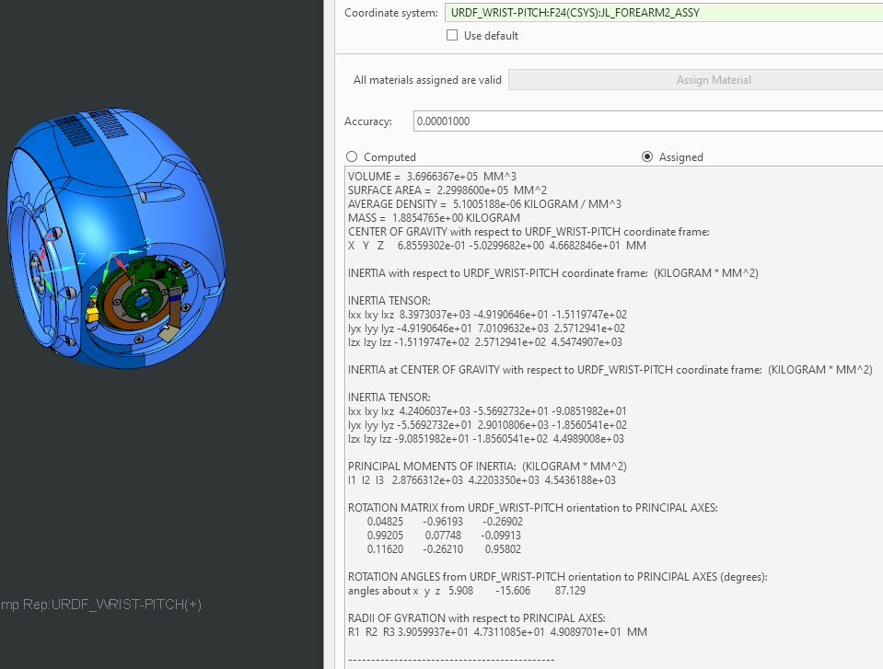

VOLUME = 3.6966367e+05 MM^3

SURFACE AREA = 2.2998600e+05 MM^2

AVERAGE DENSITY = 5.1005188e-06 KILOGRAM / MM^3

MASS = 1.8854765e+00 KILOGRAM **REAL Mass** =1.861

CENTER OF GRAVITY with respect to URDF_WRIST-PITCH coordinate frame:

X Y Z 6.8559302e-01 -5.0299682e+00 4.6682846e+01 MM

INERTIA with respect to URDF_WRIST-PITCH coordinate frame: (KILOGRAM * MM^2)

INERTIA TENSOR:

Ixx Ixy Ixz 8.3973037e+03 -4.9190646e+01 -1.5119747e+02

Iyx Iyy Iyz -4.9190646e+01 7.0109632e+03 2.5712941e+02

Izx Izy Izz -1.5119747e+02 2.5712941e+02 4.5474907e+03

INERTIA at CENTER OF GRAVITY with respect to URDF_WRIST-PITCH coordinate frame: (KILOGRAM * MM^2)

INERTIA TENSOR:

Ixx Ixy Ixz 4.2406037e+03 -5.5692732e+01 -9.0851982e+01

Iyx Iyy Iyz -5.5692732e+01 2.9010806e+03 -1.8560541e+02

Izx Izy Izz -9.0851982e+01 -1.8560541e+02 4.4989008e+03

PRINCIPAL MOMENTS OF INERTIA: (KILOGRAM * MM^2)

I1 I2 I3 2.8766312e+03 4.2203350e+03 4.5436188e+03

ROTATION MATRIX from URDF_WRIST-PITCH orientation to PRINCIPAL AXES:

0.04825 -0.96193 -0.26902

0.99205 0.07748 -0.09913

0.11620 -0.26210 0.95802

ROTATION ANGLES from URDF_WRIST-PITCH orientation to PRINCIPAL AXES (degrees):

angles about x y z 5.908 -15.606 87.129

RADII OF GYRATION with respect to PRINCIPAL AXES:

R1 R2 R3 3.9059937e+01 4.7311085e+01 4.9089701e+01 MM

---------------------------------------------

T matrix “forearm-yaw” to “wrist-pitch”

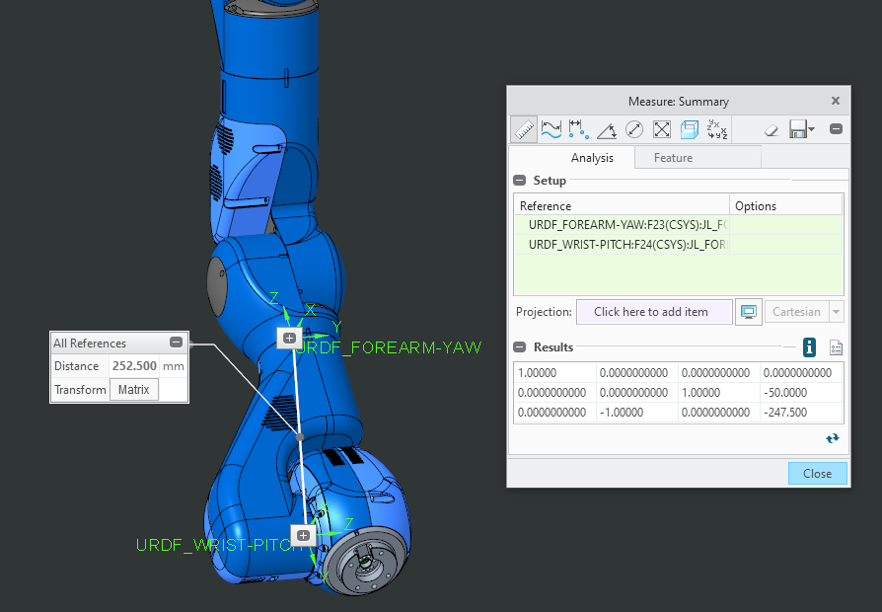

Urdf wrist-roll

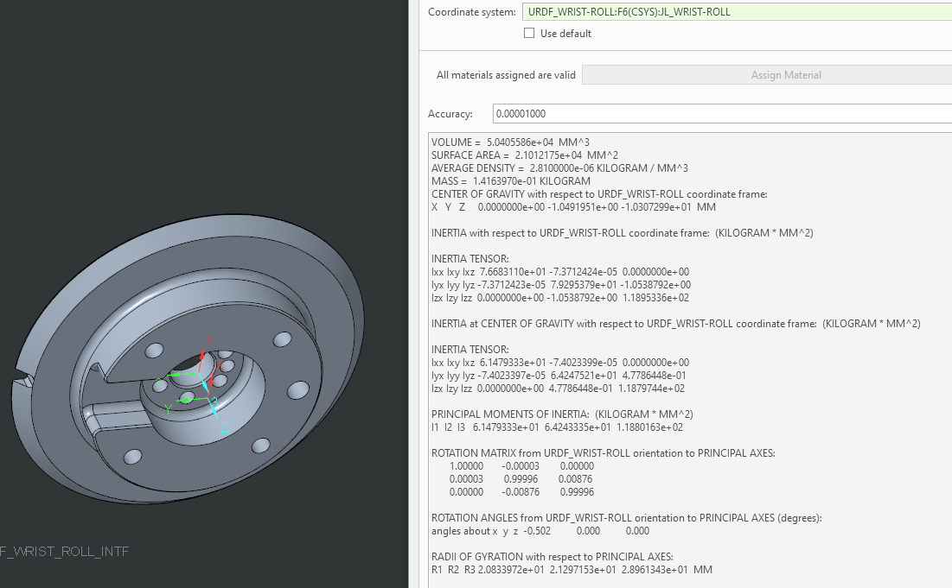

VOLUME = 5.0405586e+04 MM^3

SURFACE AREA = 2.1012175e+04 MM^2

AVERAGE DENSITY = 2.8100000e-06 KILOGRAM / MM^3

MASS = 1.4163970e-01 KILOGRAM

CENTER OF GRAVITY with respect to URDF_WRIST-ROLL coordinate frame:

X Y Z 0.0000000e+00 -1.0491951e+00 -1.0307299e+01 MM

INERTIA with respect to URDF_WRIST-ROLL coordinate frame: (KILOGRAM * MM^2)

INERTIA TENSOR:

Ixx Ixy Ixz 7.6683110e+01 -7.3712424e-05 0.0000000e+00

Iyx Iyy Iyz -7.3712423e-05 7.9295379e+01 -1.0538792e+00

Izx Izy Izz 0.0000000e+00 -1.0538792e+00 1.1895336e+02

INERTIA at CENTER OF GRAVITY with respect to URDF_WRIST-ROLL coordinate frame: (KILOGRAM * MM^2)

INERTIA TENSOR:

Ixx Ixy Ixz 6.1479333e+01 -7.4023399e-05 0.0000000e+00

Iyx Iyy Iyz -7.4023397e-05 6.4247521e+01 4.7786448e-01

Izx Izy Izz 0.0000000e+00 4.7786448e-01 1.1879744e+02

PRINCIPAL MOMENTS OF INERTIA: (KILOGRAM * MM^2)

I1 I2 I3 6.1479333e+01 6.4243335e+01 1.1880163e+02

ROTATION MATRIX from URDF_WRIST-ROLL orientation to PRINCIPAL AXES:

1.00000 -0.00003 0.00000

0.00003 0.99996 0.00876

0.00000 -0.00876 0.99996

ROTATION ANGLES from URDF_WRIST-ROLL orientation to PRINCIPAL AXES (degrees):

angles about x y z -0.502 0.000 0.000

RADII OF GYRATION with respect to PRINCIPAL AXES:

R1 R2 R3 2.0833972e+01 2.1297153e+01 2.8961343e+01 MM

T matrix “wrist-pitch” to “wrist_roll”

